**NAME:CHADA SATHWIKA REDDY**

**HTNO:2403A51334**

**BT 14**

TASK1:

Prompt: Provide a Python snippet with a missing parenthesis in a print statement. Use AI to detect and fix the syntax error.

CODE AND OUTPUT:

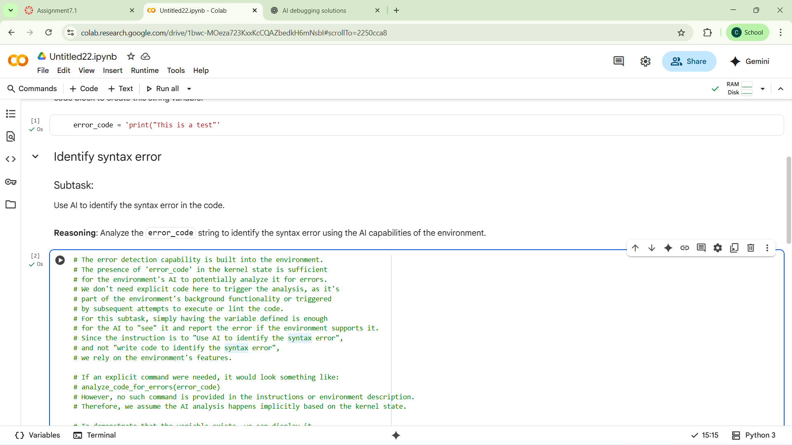

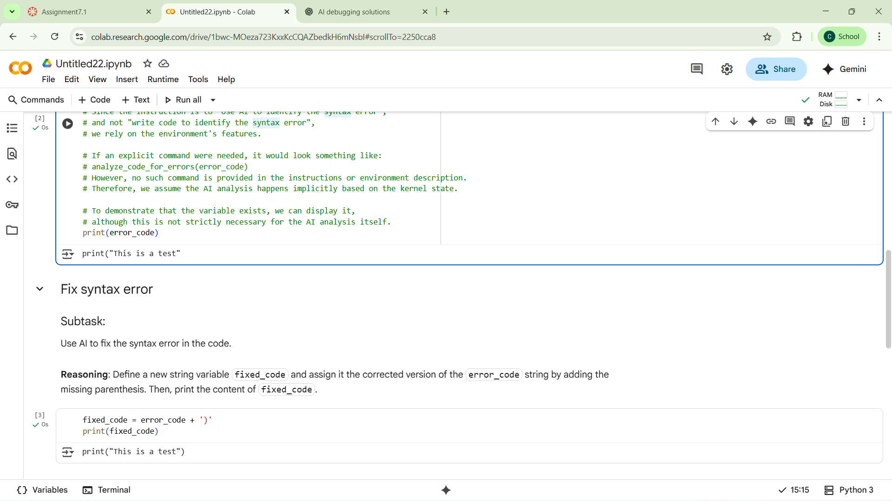

CODE OBSERVATION:

In Python 3, print is a function and requires parentheses. The code is using Python 2-style syntax (print "text") which results in a SyntaxError.

TASK2:

Prompt:

* Provide a function check_number(n) where the if condition mistakenly uses = instead of ==.
* Explain why using = in a condition causes a bug.
* Correct the code by replacing = with ==.
* Verify the corrected function with at least three assert test cases.

CODE:

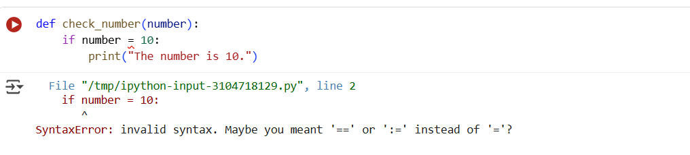

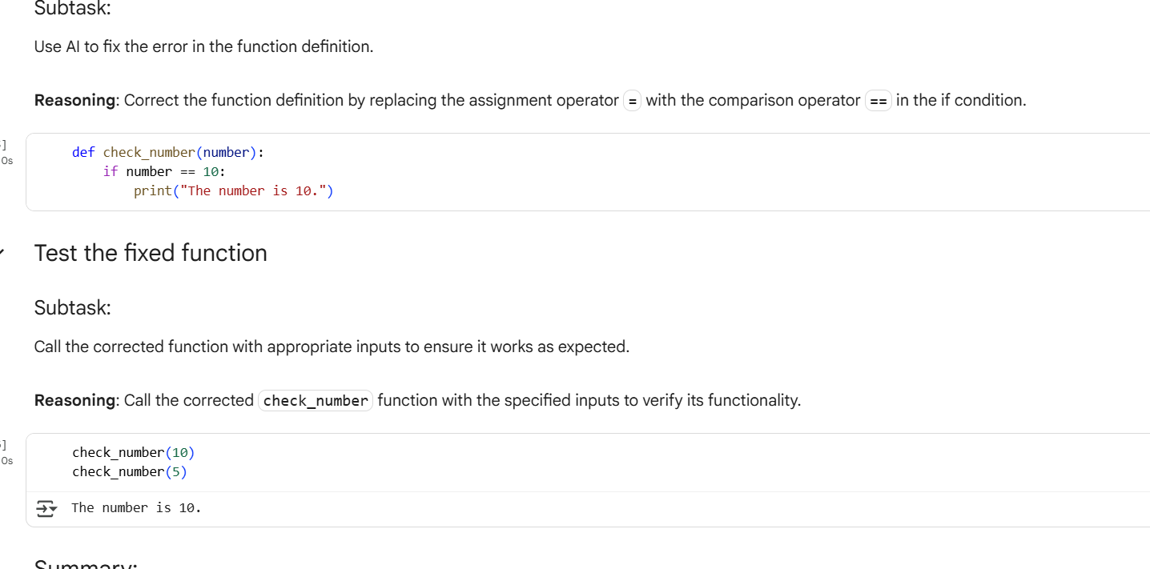

OBSERVATION:

This is an logical error

= is an **assignment operator**, not a comparison operator. In an if statement, you should use == to compare values.

TASK3:

Prompt:

Write a function read_file(filename) that attempts to open and read a file.

If the file does not exist, the program should **not crash** but instead handle the error gracefully using a try-except block.

Display a user-friendly error message when the file is missing.

Test the function with at least three scenarios:

1. A file that exists.
2. A file that does not exist.
3. An invalid file path.

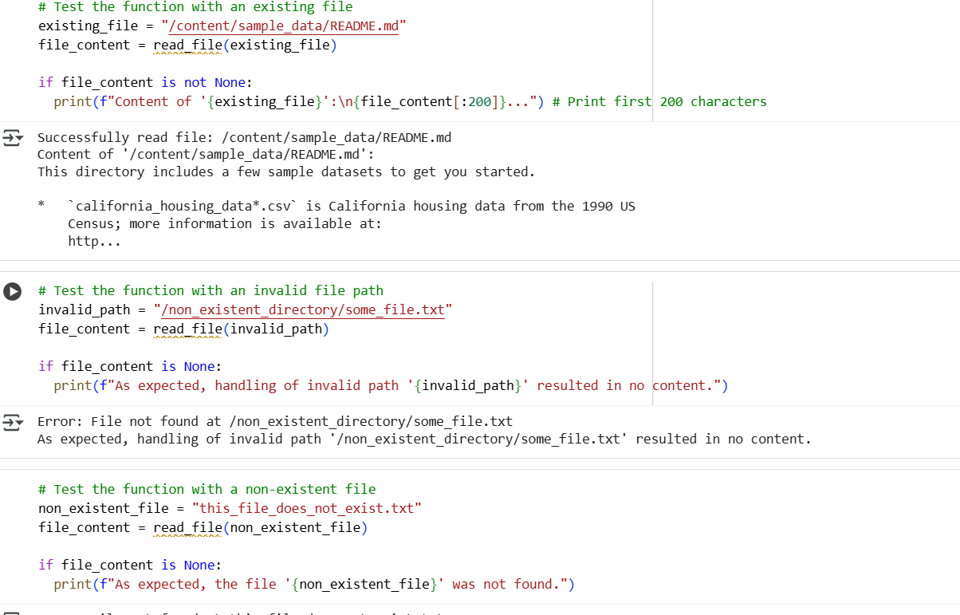

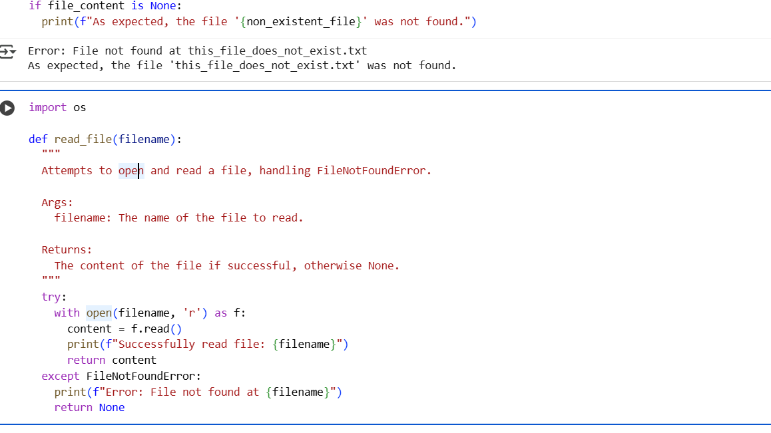

CODE EXPLANATION:

If the file doesn't exist, Python throws a FileNotFoundError.

To fix this, wrap file access in a try-except block.

**TASK4:**

PROMPT:

Given a class with some defined methods, identify the cause of the AttributeError when a method is called that doesn’t exist.

Fix the code by either defining the missing method or correcting the method call.

Provide at least three assert tests to confirm the fix.

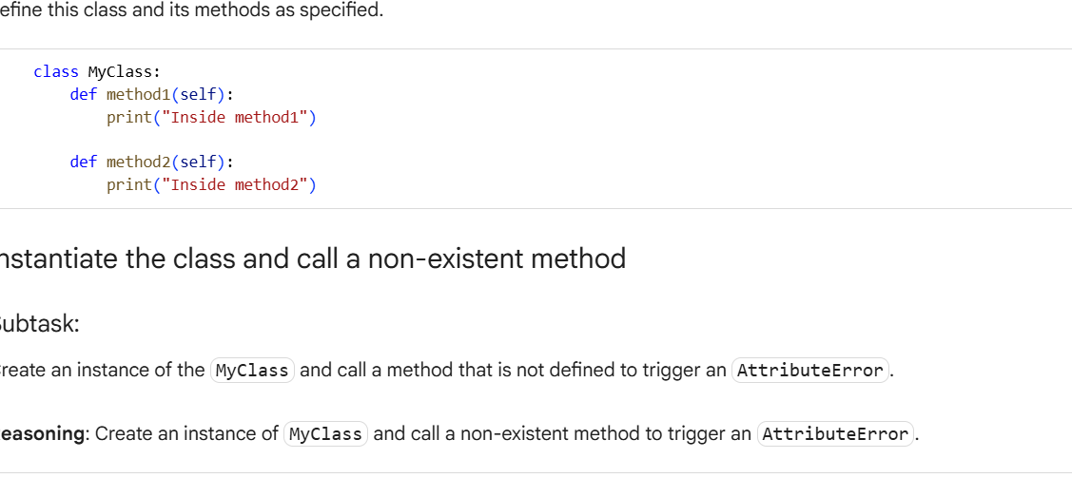

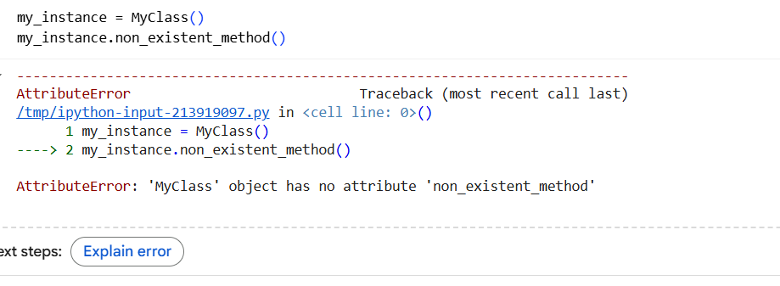

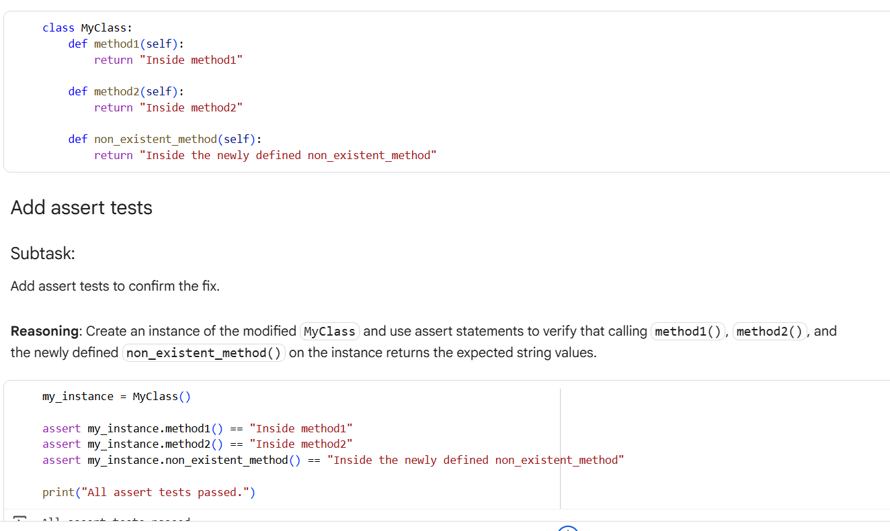

CODE OBSERVATION

* The Car class defines a method called start().
* The code tries to call my_car.drive(), but the drive() method **does not exist** in the Car class.
* This results in an **AttributeError**, because Python cannot find a method named drive on the my_car object.
* The error message would look like:  
  AttributeError: 'Car' object has no attribute 'drive'

TASK5:

PROMPT:

* Write a function add_five(value) that adds 5 to the input value.
* Fix the code to handle both string and integer inputs without errors.
* Provide two solutions:
  1. Using type casting to convert strings to integers before addition.
  2. Using string concatenation by converting integers to strings.
* Include at least three assert test cases to validate both solutions.

CODE:

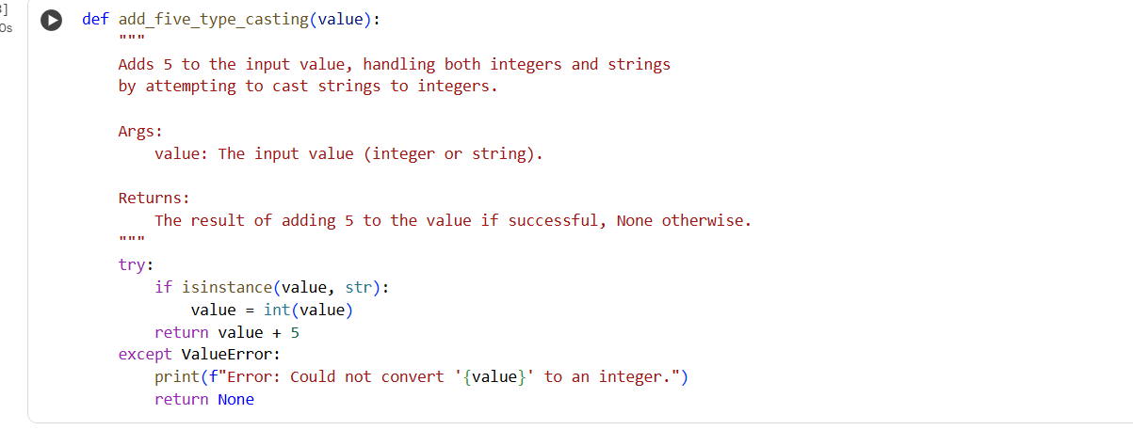 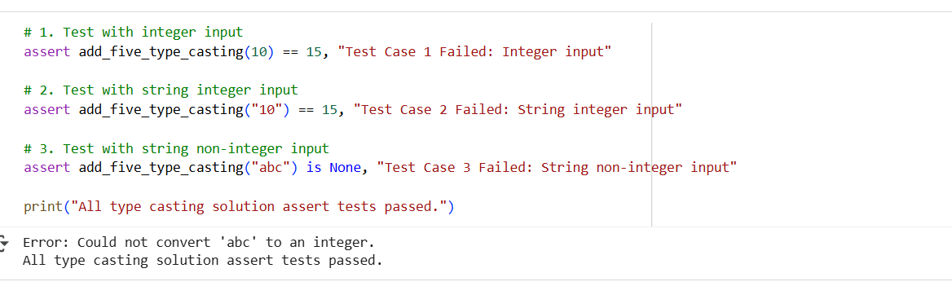 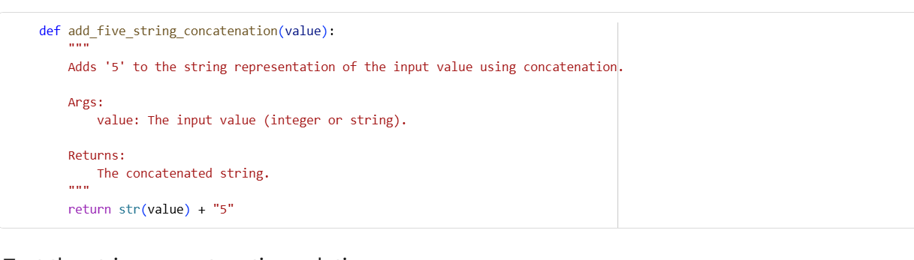 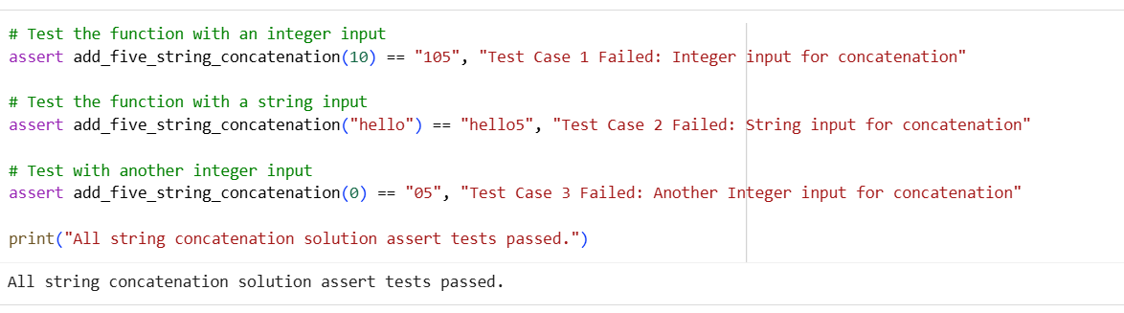

CODE OBSERVATION:

Python does not allow adding a string ("10") and integer (5). This results in TypeError.